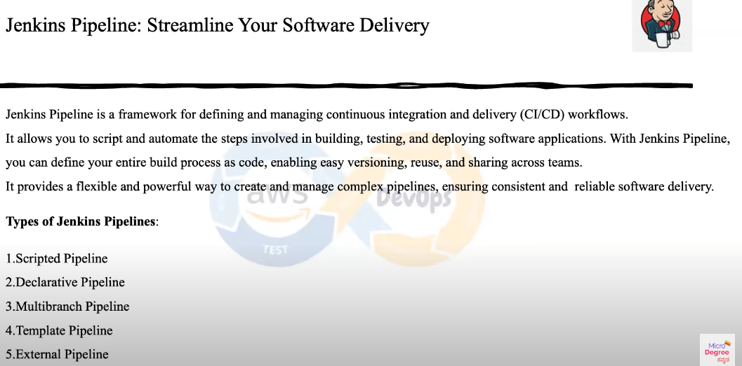

Java and Jenkins install.  
sudo su –

Systemctl status Jenkins

--------------install Jenkins------------

# Step 1: Install Java

sudo yum update -y

sudo yum install java-11-openjdk-devel -y

java -version

# Step 2: Install Jenkins

sudo wget -O /etc/yum.repos.d/jenkins.repo https://pkg.jenkins.io/redhat-stable/jenkins.repo

sudo rpm --import https://pkg.jenkins.io/redhat-stable/jenkins.io.key

sudo yum install jenkins -y

# Step 3: Start and Enable Jenkins Service

sudo systemctl start jenkins

sudo systemctl enable jenkins

sudo systemctl status jenkins

# Step 4: Configure Firewall (If Enabled)

sudo firewall-cmd --permanent --zone=public --add-port=8080/tcp

sudo firewall-cmd --reload

# Step 5: Get Jenkins Unlock Key

sudo cat /var/lib/jenkins/secrets/initialAdminPassword

# Step 6: Install "Role-based Authorization Strategy" Plugin

# (Manual step: Use the Jenkins UI)

# Step 7: Create User and Manage Roles

# (Manual steps in Jenkins UI)

# Step 8: Add a New User via Jenkins UI

# (Manual step: Go to Manage Jenkins > Manage Users > Create User)